Record No: 0664
MARGARET LUCY STARKEY (Greta)

of 59 Queensgate Mews, London SW7

Youngest daughter of Sir John Starkey (0665) of Norwood Park, Southwell by his wife Emily, dau of Sir Charles Seely.

Birth: 21 Nov 1903, in Mansfield,Nottinghamshire
Marriage: 28 Jun 1927, at Southwell Minster, Nottinghamshire to James Aubrey
Henry Bellingham Somerville (0663)
Death: 20 Nov 1986, in London Bd 28 November, 1986 St Michael’s Churchyard, Halam,
Nottinghamshire

Source: Somerville Index

Notes:

Birth Registered between Oct and Dec 1903:
Margaret Lucy Somerville born in Mansfield, Nottingham.

Shipping records: Arrival at Southampton on 12 Jan 1925, from Buenos Aires on the
Almanzora, Address: Norwood Park, Southwell. Aged, 21.

Death Index: Registered in Kensington and Chelsea, London:
Margaret Lucy Somerville, born 21 Nov 1903, died Nov 1986.

Name: | Margaret Lucy Somerville
Birth Date: | 21 Nov 1903
Date of Registration: | Nov 1986
Age at Death: | 83
Registration district: | Kensington and Chelsea
Inferred County: | London
Volume: | 13
Page: | 1608

London, England, Death Notices from The Times, 1982-1988 about Margaret Lucy Somerville
Name: | Margaret Lucy Somerville
Age: | 82
Birth Year: | 1904
Death Date: | 20 Nov 1986
Published Date: | 28 Nov 1986

Dorothy Rooke, who was a bridesmaid at Jim (0663) and Greta’s wedding, used to contrast the Starkey family and guests with the Somerville family; she said the former were rather grand and stuffy, while the latter were having a good time. She was mortified that the Somerville children were to be seen and not heard, being confined to the Nursery floor. Somewhere WBRBS has a family picture taken after the wedding on the steps of the garden front of Norwood. Many years later (59 to be precise), after Greta’s funeral, which Tommy Rooke, Peter Truell and WBRBS attended, a similar Starkey/Somerville photograph was taken on the same steps.

Greta very kindly gave WBRBS Jim’s second signature ring for his son James, following a visit to Dargle Hill. His first signature ring (given to Jim by his mother) was lost while bathing in a lake in Kashmir. During the visit, it was discovered that the Starkey family were neighbours and friends of Sir Charles Birkin, who had lived at Dargle Hill from about 1950 to 1961 and been responsible for enlarging and considerably improving the property.

Greta, who had a wide circle of friends, even while she and Jim lived at Clermont for a while in 1949/1950, always appeared ‘vague’ and some would say ‘scatty’. When she moved to Queensgate Mews, she led a secluded life. Jim had contemplated living in Ireland when they were at Clermont, but his early death intervened.

WBRBS from personal knowledge and conversation with Dorothy Rooke
www.ancestry.co.uk

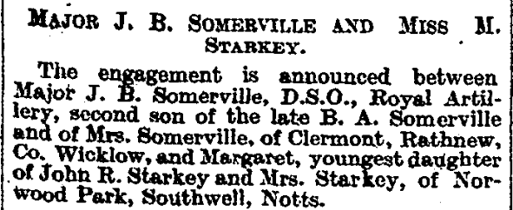
The Times, 7 Apr 1927

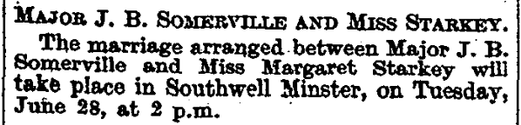
The Times, 24 ,May 1927
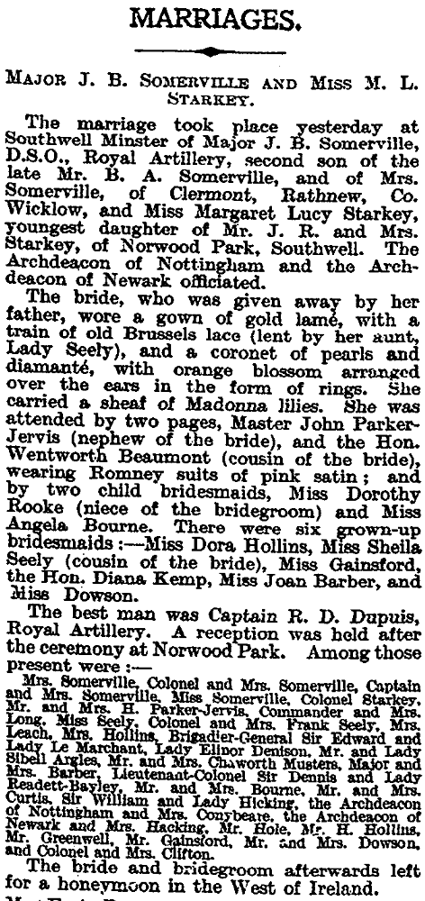

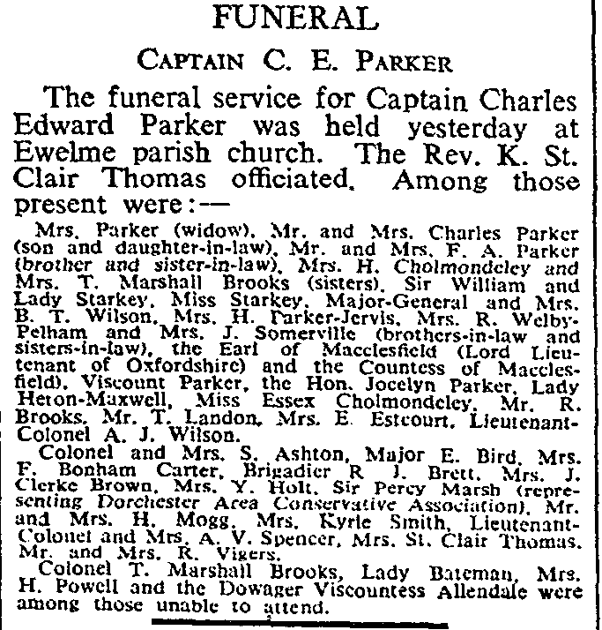
The Times, 24 Mar 1962

